Steelscape Metal Blog Topics
In this document are a series of articles which can be reposted on your website or blog to contribute to your technical guidance as a metal roofing pro.
These are just some of the blog topics that Steelscape has developed based on our extensive knowledge of metal, metal coatings and color technology. If you have a specific topic you would like addressed or additional blog topics, reach out via ‘Ask Steelscape’ at Steelscape.com.

10 Common Mistakes When Selecting a Metal Finish
Metal products make for excellent roofing and siding solutions. They provide excellent durability, offer long warranties, and offer a variety of vibrant and versatile colors. Selecting the right finish for a metal roof and wall project is one of the most important decisions in the project journey. The metal finish is critical to aesthetic appeal, corrosion resistance, and solution longevity. This list outlines several common mistakes, strategies to avoid them, and where to go for more information.
1) Selecting the wrong paint system relative to project needs
A paint system refers to the combination of different coatings applied to the metal, this typically includes a primer and a topcoat. The paint system is engineered to provide a mix of durability, performance, and affordability. There are three prominent paint systems for pre-painted metal. Awareness of the different attributes of these paint systems is important when assessing the suitability of a paint system for a specific application. Paint system selection can significantly impact a project’s cost, performance, and warranty coverage. The three common paint systems include; standard polyester, silicone modified polyester (also known as SMP or enhanced polyester), and fluorocarbon/polyvinylidene fluoride (also known as PVDF or under the trademarked names Kynar 500® and Hylar 5000®). Paint systems range in performance from good (polyester), to better (SMP), to best (PVDF), although modern paint system development has narrowed the differences between a high-end standard polyester system and an SMP system. Polyester paint systems are typically the most economical paint system and offer the lowest level of UV resistance when compared to SMP and PVDF systems.
2) Not understanding the impact of color pigmentation
Pigments impart color to paint and are either organic or inorganic. Organic pigments are typically derived from plants, whereas inorganic pigments are metallic compounds or oxides that are further processed to provide improved color stability. Organic pigments are usually brighter than inorganic pigments and can provide a cleaner or more distinctive look. However, organic pigments are less durable and fade faster when exposed to ultraviolet (UV) light, a key consideration for exterior building design.
For certain colors, namely bright or exotic colors using organic pigments, a clear coat is an optional (final) layer that can be applied over the top to provide another layer of protection and fade resistance.
3) Not reading the warranty coverage of the finish selected
Some installers or product manufacturers often market a headline ‘30-year warranty’ without providing complete details of the warranty coverage. Typically, headline warranties refer to a finish warranty. Finish warranties cover attributes associated with the paint, including that it won’t delaminate and come off, or that the color won’t fade excessively. Finish warranty coverage will vary based on the type of paint system selected. Finish warranties do not provide coverage for the weather-tightness of the installed solution, panel consistency, or installer workmanship.
4) Not taking into consideration the environment in which the solution will be installed
Pre-painted metal is a highly versatile material for roofing and siding applications. However, certain extreme environments can prematurely reduce the lifespan of a metal product and additional paint modifications may be required to provide robust protection and long-term warranty coverage. The two key extreme environments include coastal environments, which expose a building to excessive salt spray, or industrial environments, which may expose the metal to chemical spray.
Product options to prepare for these environments include high-build primers or the application of clear coats. These additional paint layers provide an extra barrier of protection. Not only are these systems more durable, but they may also enable the creation of a warrantable finish despite the environmental extremes. The best way to understand if the finish will require modification for the installed environment, look at provisions outlined in warranty documentation or speak to a knowledgeable supplier.
5) Not accounting for batch sensitivity when ordering material or when building a project in stages
Certain paint options are batch sensitive in nature due to their complex finishes. These include metallic or mica paints, translucent resins, or printed designs. Due to the unique way in which these colors are produced, their size and orientation cannot be completely controlled during production, creating slight variations from batch to batch. While in isolation the difference is difficult to identify, when installed directly next to one another, the minor differences can become apparent, distracting observers, and detracting from the clean, uniform look of the surface.
Product manufacturers will identify on a color card or color samples if the identified color is subject to batch to batch variation.
6) Not being aware of all the different finish options available
Metal has expanded beyond the handful of standard colors from yesteryear. The diversity of colors and versatile palettes available today are designed to complement a variety of structure types, geographic regions, and emerging building trends. Finishes have also expanded to include more than solid colors. New finishes include textured paints, ultra-low gloss matte products, unique printed designs that recreate other finishes, or translucent resins that provide dynamic interaction with light. These new finishes still carry the same long warranties and high-end performance that has made metal a popular roofing and siding material.
7) Thinking that metal is painted like a wall inside your house
Unlike other building products, metal is painted before it is formed into a finished product such as metal roof and wall panels. For field applied paints, such as stucco, paint consistency is determined by the individual painter. By comparison, metal paint is applied using huge, specialty lines. This process creates a quality, highly consistent finish that contributes to metal’s unparalleled finish consistency, longevity once installed, and resistance against the elements.
To run efficiently, these lines run at hundreds of feet per minute in large production batches and these optimized manufacturing processes can restrict the number of color options available. This is why the color card of most metal products is defined, compared to the thousands of options available for interior paints. Metal can still be coated in any color, or modified to meet a project-specific needs, but these custom requests may incur additional charges, order minimums, and longer lead times.
8) Off put by industry jargon and complex terms
Metallic coating, gauge, polyvinyl difluoride are just some of the common terms a specifier or homeowner may encounter when trying to determine an appropriate finish for a project. Despite this perceived complexity, many of the terms are straightforward and can be demystified by spending a few minutes reading or listening to the right educational content.
9) Making decisions based on a computer screen
The perceived difference between individual colors on a color card may look minor, however, the impact once installed can be significant. Given this potential impact, obtaining samples before making a color decision is very important. Digitized colors can be influenced by several factors including the settings of your monitor and the settings used when the digital swatch was created. This variance can make digital comparisons difficult. There is not an industry standard for color naming conventions, which can further make color comparisons difficult. For example, one manufacturer’s ’dark bronze’ may be the same, or different, to that of a competitor.
10) Not asking if the color is ‘cool’
Most modern metal colors today use ‘cool’ pigmentation. ‘Cool’ pigments refer to paints with specially developed pigments that reflect infrared UV light. This light, generated by the sun, leads to the build-up of heat within structures. By reflecting this light, buildings can remain cooler in summer, reducing cooling costs. Cool pigmentation is available across all the common metal roof and wall colors and in most instances does not come at an additional cost to the end-user. So why wouldn’t you want a more efficient color? When selecting a color, identify if it uses ‘cool’ pigmentation.
These are just some of the common mistakes made when selecting a metal roof and wall finish. For more metal finish resources visit Steelscape.com

An Overview of Metal Roof and Wall Finish Warranties
Warranties form an important part of the purchase decision when selecting an exterior building material. They influence product and supplier perception and reinforce peace of mind for the building owner. For typical exterior metal applications such as metal roofing and siding projects, three distinct warranties can be offered, including finish warranties, roof or wall product performance warranties, and installer warranties that cover workmanship. The finish warranty is typically offered by the paint vendor; however, sometimes these may be offered directly by the coater by or end-product manufacturer.
It is important to understand these roles when validating potential suppliers and installers and when pursuing a warranty claim. Building owners must ensure they are aware of the coverage of each individual warranty to avoid coverage gaps in the event of a claim. For example, some products may offer a headline ‘30 year’ warranty, but this coverage may only reflect the adhesion of the paint rather than any other aspects of the installed solution.
Unlike other building materials, most metal building products are painted before they are formed into finished products. This is done in controlled environment using a dedicated process called coil-coating. The advantage of this process is it creates a highly consistent, high-performance and long-lasting painted material with long finish warranties.
Finish warranties typically warrant against three different forms of excessive deterioration. They are excessive chalking, color fade, and delamination of the topcoat or primer (called film integrity).
Chalking is caused by the degradation of the resin system of the painted surface, mainly due to UV rays. As the resin breaks down, resin particles along with imbedded pigment particles lose adhesion and take on a white appearance. The physical similarity of these particles to chalk underpins the term ‘chalking’. The amount of chalking that is identified as excessive is determined based on an ASTM developed 0-10 scale. 10 represents no chalking to the product.
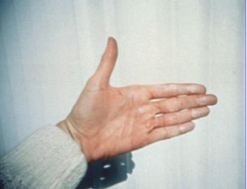
An example of excessive chalking
Fading is caused when UV rays and substances in the environment attack the pigments in the paint and cause their color to change. Color change is assessed based on its variance to the base state when new. Color change is measured by delta E (also known as NBS Units), which is a numerical value that represents total color change from a base. A warranty will outline acceptable units of delta E variance over the lifespan of the product. For reference, a human eye can detect a change in color between 0.5 and 1 delta E units.

Change in color between 0 and 7 NBS (dE) units for blue and red colors
Delamination is the loss of paint adhesion to the metal or between the primer and the topcoat. It can be visually apparent in several forms including bubbling, peeling, checking, chipping, cracking, or complete loss of the topcoat. Warranty coverage will ensure that the surface retains a consistent finish without the presence of any signs of delamination for the warranty period.
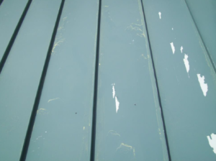
A visible example of finish delamination

Coverage against these three items, and the length of this coverage, will vary significantly by the paint solution offered. The three common paint systems, from good to best, are polyester, silicon modified polyester (SMP) and polyvinylidene fluoride (PVDF). Economical polyester systems will generally only cover against paint delamination whereas high-end polyester systems may have warranties that cover color, chalk and film integrity. By comparison, most PVDF systems will offer warranties for chalking, color fade, and film integrity. This highlights that all paints are not equal and the importance of understanding the formulation and paint system that is being offered as part of a project solution.
Other Considerations
Finish warranty coverage can also vary based on the proximity to certain environmental factors such as industrial environments or coastal applications. In some instances, in order to obtain a finish warranty, the finish may require modification such as the application of a thicker primer or a clear coat to provide additional corrosion resistance. The excerpt below (a sample PVDF warranty), outlines the variance in coverage and additional product requirements based on the installed environment.
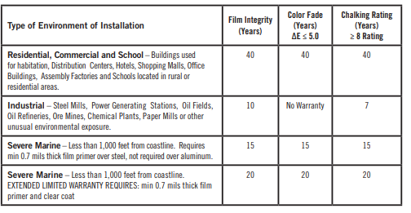
Excerpt from a PVDF warranty – Warranty Coverage Table

A warranty will also outline other useful information such as the recommended maintenance regime and other important exclusions. For example, Steelscape paint warranties recommend that the surface be washed regularly, either by sweet or tap water or by cleaning with common detergents containing less than 0.5% phosphate dissolved in one gallon of water, followed immediately by a clear water rinse.
For more information on finish warranties related to metal, visit Steelscape.com

Batch and Direction Sensitivity on Metal Roof Surfaces
Metal is a versatile roofing and siding material that offers a wide variety of vibrant color options. This color can be used for a vast range of purposes, from memorable design accents to elevated corporate identity. When selecting a color, an important element to consider is if it is batch or direction sensitive. Failure to properly manage these colors can lead to solution imperfections that may detract from the installed visual appearance of a structure.
Most solid metal colors do not exhibit batch or direction color sensitivity. Common colors are solid hues such as whites, browns, greens, and blues found on manufacturer standard color cards. Batch and direction sensitive products are primarily associated with premium or specialty products including micas or metallics, translucent resins and printed designs. Designers and specifiers may select these premium finishes for enhanced visual appeal, color depth, or design distinctiveness.
Why are these colors sensitive?
Batch or direction sensitivity can occur for several reasons, including pigment design, paint system composition, or the production process. Mica or metallic products use specially formulated pigments that are added to standard paints to create a light-catching effect. Individual mica pigment particles are flat, allowing for light to reflect at various angles, creating a distinctive visual appearance. This creates additional depth and dynamic interaction with light. Common micas include silver, bronze, champagne, and copper tones. As these pigments are flat, it is difficult to control the way they fall and appear within the paint. This leads to variations between batches and color which changes based on viewing direction.
Translucent resins provide additional color depth, as they allow the distinctive surface of the base metal to be somewhat apparent. These systems do not have a primer, and this makes them more sensitive to the composition of the base metal underneath, and the thickness of the resin applied. These properties vary slightly between batches.
Printed designs such as rust, copper patina, or woodgrain are used to evoke weathered metal or alternate materials, but with the reassurance of a traditional warranty. These products are manufactured by applying the print over the top of a solid base color using applicator rolls. This process is highly sensitive to production inputs, such as the pressure of the applicator roll, line speed, and paint viscosity, leading to slight batch-to-batch variation.
Visual impact
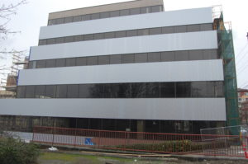
While less prevalent compared to the first image, in this wall project panels (with a mica paint) are sourced from different batches, leading to non-uniform color.
Metal finishes are produced using narrow production tolerances and must pass color-specific acceptance tests. As a result, the degree of color variation between these sensitive colors is relatively minimal. However, when installed directly next to one another or when illuminated by bright light, the color variance becomes pronounced. These sensitivities are most visible when the product is used on a flat surface such as a flush panel, or in a highly visible location that interacts with light. The two examples below demonstrate the visual impact of failing to account for this during installation.

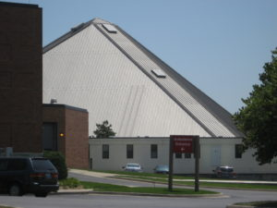
On this steep slope roof (a resin product), three panels were installed in a different direction, creating a noticeable pattern once illuminated by the sun.
Strategies for success
Validate if the desired color is batch or direction sensitive. Guidance is commonly published within product literature, or on a product manufacturers’ color card. If this is ambiguous, contact the product manufacturer.
Overcome batch mixing by accurately estimating the amount of material required for the job. This may include holding surplus material for anticipated building additions or unforeseen trim pieces until the job is complete, ensuring the material (coil number) or batch number, is recorded when stored.
Ensure the installer appropriately stages material, and mounts panels in a singular direction. Many metal products feature asymmetric designs that make installation in a singular direction straightforward, but this does not apply to all products. Where this issue is most prevalent is when flat stock is used to manufacture trim and accessory pieces either by the roofer or on the job site. Some product manufacturers assist this process by providing directional arrows on the strippable film applied to the metal. Strippable film refers to a plastic film applied to the metal to prevent transport and installation damage. This film is removed once the metal is installed. Alternatively, some metal coaters can print directional arrows on the backside of the painted metal surface to provide additional directional guidance.

For additional information about managing batch and direction paint sensitivities, contact your metal product manufacturer, or metal coater. You can also contact Ask Steelscape with any questions you may have about Steelscape metals.

Energy Efficient Cool Colors in Today’s Metal Roofing
When it comes to energy efficiency, building materials matter. With today’s metal coating paint technology, metal can be coated (painted) to enhance performance which helps to drive down energy use and allows a building to work with the environment. This is achievable through cool colors which are made up of cool paint pigments. These pigments are altered chemically and physically to reflect infrared wavelengths while absorbing the same visible light(1). The purpose of these pigments is to minimize heat buildup; reducing cooling costs of a structure. Homeowners can achieve a green design that delivers on long-lasting beauty and performance while saving on energy costs. One way to maximize on this is to select from cool colors and pigments that offer the best performance.
There is a misconception around metal roofs causing a home to be extremely hot in the summer versus other roofing materials; however, the reality is not so simple. Metal roofing using cool colors impact a home’s internal temperature, but in a good way. The use of cool colors helps decrease internal temperatures in comparison to traditional roofing materials. A lower temperature inside a home is accomplished through the cool colors’ ability to reflect sunlight and heat away from a building which is often referred to as the Heat Island Effect.(5) This effect occurs when there is a rise in outdoor urban air temperature caused by the concentration of roads, buildings and other structures that absorb heat.(4) See the diagram below from the Cool Roof Rating Council.(3)
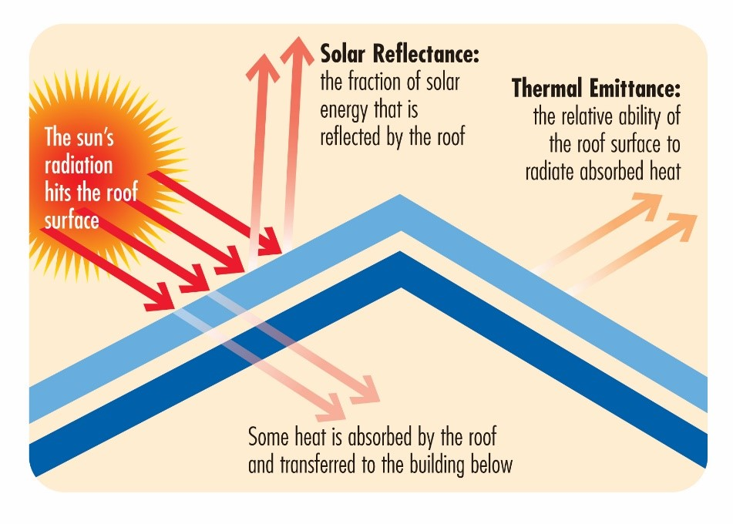
As shown above, solar reflectance and thermal emittance are the two primary factors in determining how cool a metal roof is. Solar reflectivity refers to the ability to reflect sunlight (and heat) away from a roof/ building. Thermal emittance refers to the ability to release absorbed heat(2) simple way to quickly gauge a material’s “coolness” is to look at its Solar Reflectance Index (SRI) data. SRI is measured on a scale of 0-100 with 100 being the “coolest” possible. This measurement is very important in determining how well metal roofing and its color will work on a roof.
Metal roofing utilizing cool colors are known to have energy savings ranging from 7%-15% of overall cooling costs. Since more heat is reflected, energy bills are lowered. Cool painted metal roofs retain 95% of their initial reflectance and emittance over time equaling longer lifespan over conventional roofing systems. Like all roofing projects, however, costs and energy savings can vary depending on multiple factors such as project size, project location, climate, and ease of roof access.
Moreover, metal panels are long-lasting and can be repurposed or reused. With their high recycled content, they are also 100% recyclable at the end of their lifespan.

1 https://www.steelscape.com/resources/frequently-asked-questions/
2 https://www.go-gba.org/resources/green-building-methods/cool-roofs/
3 https://coolroofs.org/
4 https://nccacoatnotes.com/2020/02/07/cant-take-the-heat-cool-walls-can-reduce-energy-costs-pollution/?fbclid=IwAR0tYuZeEGdxecZvKzotZCazaKiM6noSwpLNUHH439iF2iBcgm6rFuAeEvM
5 https://scholar.google.com/scholar?q=heat+island+effect&hl=en&as_sdt=0&as_vis=1&oi=scholart

Important Terms When Considering Metal
Outside of color selection, there are several other important attributes of a painted metal roof finish that should be considered. These include:
The Durability of the Paint System - Paint systems range from good, to better to best:
- Polyesters – the entry paint system, cost effective with a wide array of options but poorest long term UV performance.
- Silicone Modified Polyesters (also known as SMPs or Enhanced Polyesters) – Modified polyesters for improved weatherability and resistance to chalk and fade.
- Fluorocarbons (known also as PVDF / polyvinylidene fluoride or as Kynar 500® or Hylar 5000®) – The most durable paint system with exceptional resistance against UV fade and aggressive weather elements.
The Efficiency of the Color at Reflecting Heat
- Solar Reflective Index (SRI) – A value created from solar reflectance and emissivity with factors such as air flow considered, this assess how ‘cool’ a roof is and effective at reflecting heat from the structure.
How it will appear once installed
- Light Reflective Value (LRV) – Known as glare, this measures the amount of visible or usable light that reflects from a surface.
- Gloss and Sheen – Gloss and sheen are two terms used to describe visible reflection of a surface. Gloss is the measurement of visible light at a 60° angle from the surface, while sheen is measured at 85°.
The protection from corrosion
- ZINCALUME® and Galvalume® are two common names for 55% Aluminum-Zinc (Al-Zn). Aluminum offers enhanced corrosion protection over Zinc alone as it provides a protective barrier rather than a sacrificial one. These products offer a corrosion resistance warranty.
- Galvanized products refer to a coating of Znc alone. This offers strong corrosion resistance although not as good as Galvalume and will not offer a substrate warranty.

Solar Reflectance and Light Reflectance – Are They the Same?
The coatings world uses a lot of terminology that can become a bit confusing. “Reflectance” is a perfect example of a word that is used to describe two very different properties.
Light Reflectance Value
Light Reflectance Value, or LRV, measures the amount of visible or usable light that reflects from a surface. LRV is expressed as a percentage from 0 to 100; the higher the number the more visible light that is reflected. Typically, lighter colors will have a higher value than dark colors, but texture can impact LRV as well. Rough textures tend to reflect less visible light. Gloss and sheen are two other terms used to describe visible reflection of a surface. Gloss is the measurement of visible light at a 60° angle from the surface, while sheen is measured at 85°. High gloss/sheen results in high glare or shine from a surface, while low gloss/sheen surfaces have a flat or matte appearance. Glare, often a concern with pre-painted roofs, is controlled by lowering the sheen value.
Solar Reflectance Value
Solar Reflectance Value, or SRV, measures the amount of total solar radiation, visible, infrared and ultraviolet, that is reflected from a surface (Total Solar Reflectance, TSR, is used as well). SRV is expressed as a percentage from 1 to 100; the higher the number the more solar radiation that is reflected. As with LRV, light colored objects often have a high SRV while dark colors are low. However, with the advent of “cool” pigments, it is possible for a medium to dark color to have a high SRV. The higher the SRV value the cooler the surface stays in direct sunlight. Gloss and sheen values have no impact on SRV. Note: Solar Reflectance Index, or SRI, is calculated from the SRV and emittance value of a material, therefore it is also different and independent from LRV.
Light Reflectance Value ≠ Solar Reflectance Value ≠ Solar Reflectance Index
LRV and SRV and SRI are NOT the same property and cannot be used interchangeably!
While there is some overlap between LRV and SRV, and many coated surfaces may have similar LRV and SRV values, they are not the same measurement.

What is the difference between Galvanized and Galvalume (ZINCALUME)
Corrosion, also known as oxidization or rust, weakens steel and can contribute to product failure. Metals, including zinc and aluminum can be applied as a coating to provide a protective barrier against corrosion.
Metallic Coating Summary
The two common types of metallic coating are galvanized (Steelscape’s TruZinc®), and Galvalume® (also known as ZINCALUME®). Galvanized coatings consist of zinc, whereas Galvalume consists of both aluminum and zinc.
As a protective element, zinc provides a sacrificial barrier for the steel underneath - this ensures the coating will corrode preferentially to the base steel. Aluminum by comparison, provides an inherent protective barrier which prevents the spread of corrosion. As a result, Galvalume combines the benefit of preferential corrosion, while slowing its spread. This provides better overall long-term performance and superior cut edge and edge creep corrosion resistance performance. Extensive field testing has proven that Galvalume can outlast galvanized material several times, with the latest tests estimating a 60-year service life in unpainted applications^ . Licensed Galvalume products will typically carry a corrosion warranty of 20 to 25 years. This warranty is independent of any additional finish warranty provided by the paint system.
Manufacturing Process
The metallic coating is applied to the bare steel before it is painted. In most instances, the metallic coating is applied by passing the steel through a molten pot of the coating, after which it is cooled and treated to create a tightly bonded, consistent finish. This process is performed in accordance with ASTM standards A924, A653 and A792.
Variants and Specification
Metallic coating specification will vary based on type (galvanized or Galvalume), and by thickness, called coating weight. The thickness of the metallic coating will impact the longevity of the corrosion resistance. For galvanized material, the most common thicknesses are G60 and G90. The number denotes the coating of zinc per square foot. For example G60 reflects 0.60 ounces and G90 reflects 0.90 ounces per square foot.
For galvanized material, corrosion resistance is typically directly proportional to the amount of coating, in that a G90 product will be 1.5x more resistant compared to a G60 product. The most common Galvalume coating weight is AZ50 (or in some cases AZ55). AZ50 refers to 0.50 ounces of aluminum zinc coating per square foot. AZ50 forms the most appropriate coating weight for a diverse range of building applications. Due to the difference in the performance between galvanized and Galvalume, the numerical terminology does not represent an equivalency (AZ50 is not the same as G50). Due to the length of the zinc columns in the aluminum-zinc coating, a thinner AZ35 coating can create pathways for corrosion. As a result, AZ35 coatings cannot carry the Galvalume trade name and will not carry a corrosion warranty.
Some specialty applications, such as those within proximity of airborne chemicals or salt spray, may require alternative coating thicknesses. Thicker coating weights can impact other factors such as formability (ability to be formed into a panel) and cost. In these situations, specifiers should consult their preferred product manufacturer before selecting a coating
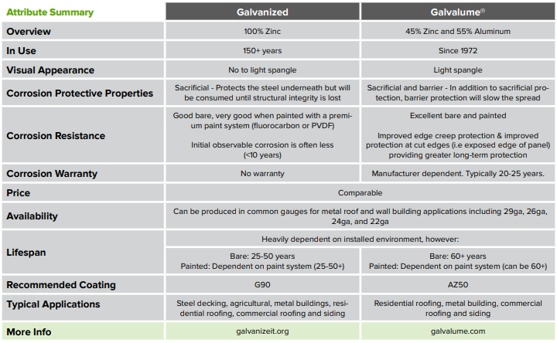
Recommendations
Galvalume (or ZINCALUME) offer superior corrosion resistance in most applications. However, when used in conjunction with a premium paint system (such as a PVDF system), both coatings will provide long-lasting corrosion protection in most environments. There are some environments in which Galvalume is not suitable including highly alkaline environments, such as those in direct contact with wet cement or when buried in soil, and animal confinement settings. To avoid premature corrosion, both coatings are not suitable for roof slopes below ¼ : 12 due to the potential for standing water. Designers should also ensure these products are not in direct contact with dissimilar metals in corrosive environments, for example, direct contact with stainless steel or copper in a coastal setting.

Which Metal Is Right For My Roof?
The primary material options for metal roof products are steel, aluminum, copper and zinc. Steel is the most economical product for roof applications and when applied with the correct metallic coating, it is highly resistant to corrosion. Steel is an exceptionally strong product and is the most widely used product for metal roofs due to the variety of finish options, availability, price, performance, and accommodating nature when formed into finished products.
Aluminum is a lighter metal that offers superior corrosion resistance to steel and is often used for coastal applications. Aluminum is softer and more malleable than steel, which means it can be used to make more complex shapes such as stamped shingles or shakes. This also means it is easier to deform and does not offer the same wind performance attributes as steel, unless a thicker more costly grade of aluminum is used.
Copper and zinc are considered exotic materials for most roof applications due to their distinctive appearance, yet significantly higher price point.
Steel and Aluminum form the basis of most modern applications of metal in building product applications. These materials have superior strength, formability and offer strong cost competitiveness.
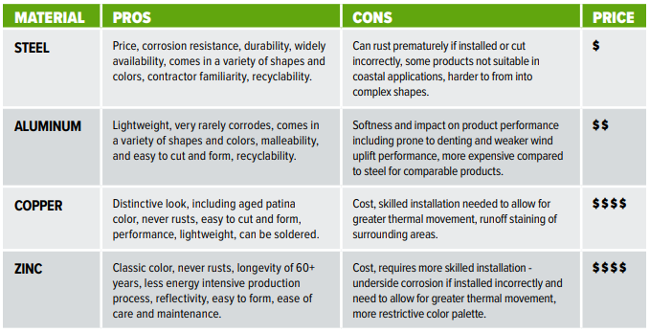

These are just some of the blog topics that Steelscape has developed based on our extensive knowledge of metal, metal coatings and color technology. If you have a specific topic you would like addressed or additional blog topics, reach out via ‘Ask Steelscape’ at Steelscape.com

